Lab Assignment 1.3
Task Description #1:
Use Copilot to generate a is_prime() Python function.

Prompt:
Print Prime no. in a range using is_prime function
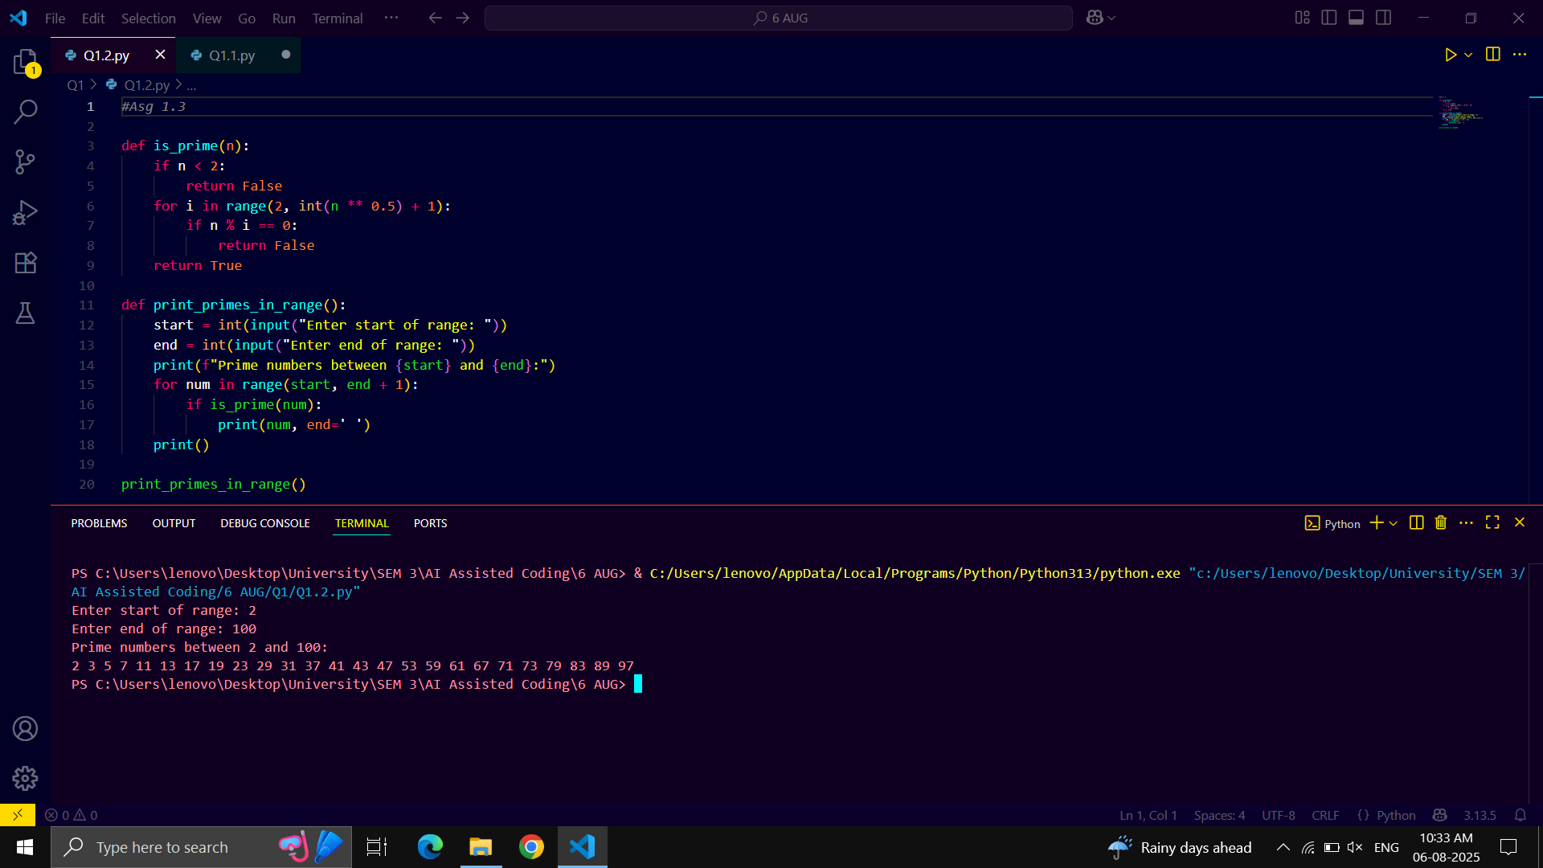

Task Description #2:
- Write a comment like # Function to reverse a string and use copilot to generate the function.

Prompt:
Write a function to find reverse of a string and print it by taking dynamic input.
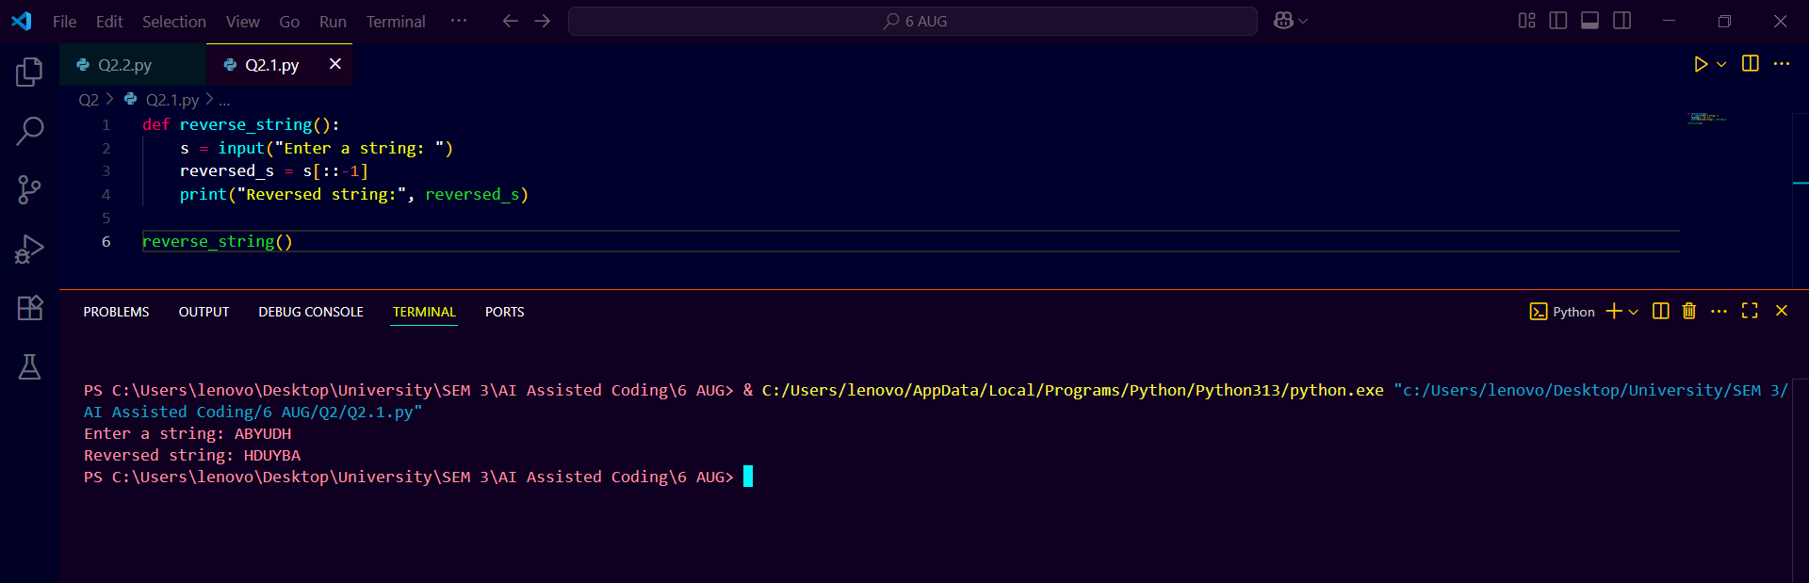

Task Description #3:
- Generate both recursive and iterative versions of #factorial function using comments.

Prompt:
Write a recursive function to find factorial of Number and print it.

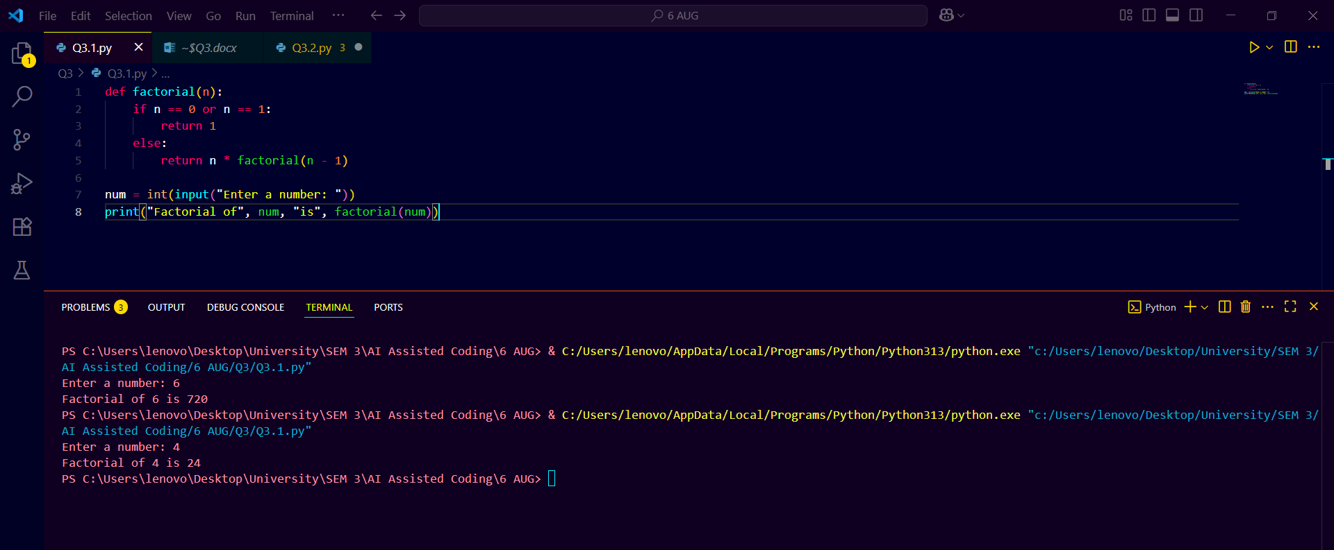

Task Description #4:
Find the largest number in a list.

Prompt:
Generate a python code to find the largest number in list with dynamic input of the list size and the list values and print the list.

